LESSON-26
The Blind Sees
Objective To learn about the miracle of Jesus
showing his power over misfortunes;
Have you seen blind people? The lame people cannot walk. The deaf cannot hear. The dumb cannot speak. What about the blind? You may just close your eyes for a while. Can you see anything? Is it not dark everywhere? That is the case with the blind. They are always in the dark. If the physical eyes are blind, we cannot see the beautiful sky or the earth decorated with plants and flowers, or our loving
Parents. What a pity it is similarly, if we are spiritually blind, we cannot see God or God's glory. Both kinds of vision are equally important.
When Jesus was on earth, He healed a man born blind with both physical and spiritual sight.
One day Jesus was going down the street of Jerusalem. He saw a man born blind sitting and begging
beside the way. His disciples asked, "Teacher, whose sin caused him to be born blind? Was it his own or his parents' sin?"
Jesus answered: "No, this is not due to anybody's sin".
Jesus Gives Sight to the Blind Man
Jesus said, "while Jam in the world lam the light of the world: After He said this, Jesus, spat on the ground and made some mud with the spittle. He rubbed the mud on the man’s eyes, and said, "Go and wash your face in the pool of Siloam". So the man went, washed his face and came back seeing.
His neighbors and those who had formerly seen him begging asked, “Isn’t
this the same man who used to sit and beg? Some claimed that he was. Others said, "No, he only looks like him."
But he himself insisted, "I am the man."
how then were your eyes opened?' they demanded.
He replied, "The man they call Jesus made me see."
Where is this man? they asked him. rrj don't know," he said.
Yet they didn't believe. So they called his parents and asked them.
His parents knew that it was Jesus who had given their son sight. But they refused to say so. Do you know why? Because the Jewish authorities had made an agreement that anyone who believed that Jesus is the Messiah would be expelled from synagogue. So they said:
We know that he is our son and that he was born blind. But we do not know how it is that he is now able to see, nor do we know who cured him of his blindness Ask him, he is old enough and he can answer for himself". By fear of the authorities, hi parents refused to testify Jesus. Like the blind man,
we must be bold enough to testify Jesus always..
Now see the testimony of the man who got sight
The Jewish authorities called the man who got sight and said: "We know that this man who cured you is a sinner"
- The man cured: / do not know if he is sinner or not One thing I know, I was blind and now! see.
They asked: What did he do to you? How did he cure you of your blindness?  The man: I have already told you. Why do you want to hear it again? May be you too, would like to be his disciples?  They: You devil! You are that  fellow's disciple. But we are Moses' disciples. We know that God spoke to Moses; as for that fellow,  however, we do not even know where he comes from. | 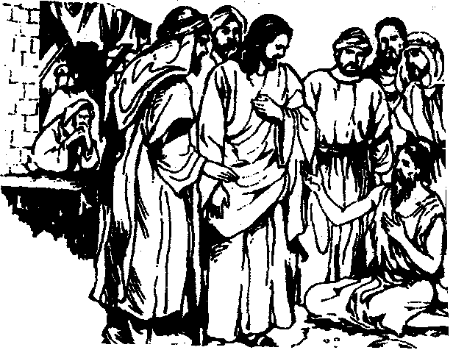

The man: What strange thing that
is! You still don't know where He is from even after He has opened my eyes! Since the beginnir the world nobody has ever heard anyone giving sight to a blind person. Unless this man came from God, he would not be able to do such a thing.
They: You were born and brought up in sin and you are trying to teach us? Go away from synagogue. Never return again.
Though the Jewish authorities saw a very clear sign, they didn't purposely believe in Jesus. I horrible is their spiritual blindness! The evil god of this world has kept the unbelievers in the and he keeps them from seeing the light shining on them, the light that comes from the Good N of the glory of Christ, who is the exact likeness of God.(2Cor. 4:4)
Jesus heard that the Jews had expelled the man cured of blindness from the synagogue. Later w Jesus met him, He asked, "Do you believe in the Son of God"?
The man answered, "Tell me who he is sir, so that I can believe in him".
Jesus said to him, you have already seen him, and He is the one who is talking with you now".
"I believe Lord", the man said and knelt down before Jesus. Thus the man received his spirituals also. He was saved.
Reference: Memory Verse
lam the light of the world. Whoever follows me will have John 9:1-14 light of life and will never walk in darkness". (John 8:12)
...................
-
1. Refer to the context (who told whom):
a) Whose sin caused him to be born blind? ................................................
b) "The man called Jesus made me see"...................................................
- 'Ask him, he is old enough .............................................................
- "One thing/know, I was blind and now i see .............................................
- "Do you believe in the son of God ......................................................
- "Go and wash your face"! ..............................................................

