Lesson 18
Jesus meets Nicodemus
There was a Jewish Teacher named Nicodemus. He was a Pharisee. He was also a member council known as Sanhedrin.
The Pharisees opposed Jesus and His teachings. But Nicodemus was a sincere man who was! the truth. When He heard about Jesus and about His mighty works, he decided to meet Him hear from Him.
Nicodemus went to Jesus by night and said to Him:  "Master, we know that you are a Teacher sent by God".  Jesus answered:  'I am telling you the Truth. No one can see the Kingdom of God unless he is born again".  Nicodemus: "How can a grown man be born again?'  Jesus: No one can enter the Kingdom of God unless he is born of Water and Spirit".  Jesus Christ explained to Nicodemus how a man can be born again. By Water | 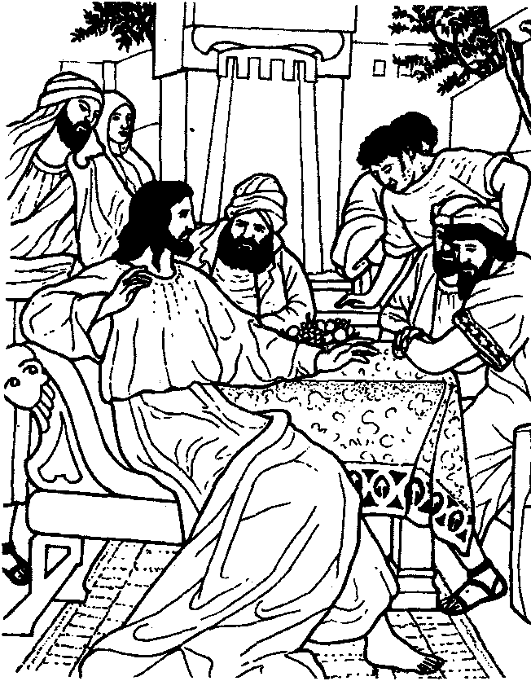

Jesus meant the Word of God. By Spirit He meant the Holy Spirit.
When we hear the Word of God, the Holy Spirit will convict us about our sin and wrongdoings. There we must confess our sins and leave them forever. The sins thus confessed must never be repeated This is meant to be Repentance. When we repent, Jesus Christ will forgive all our sins. He will make us the Children of God. Then we become a new creation, like a new-born child. This is meant to b rebirth. By repentance and rebirth we become new babes in spirit, no matter how old we are.
When we are born to our parents, we become heirs of their property and wealth. Similarly when w become the children of God by rebirth we become heirs of the Kingdom of God.
Are you born again? Are you a Child of God? If not, you cannot enter the Kingdom of God.
You pray to Jesus right now and confess your sins. You kneel down and pray:
"Lord Jesus! I admit that I have disobeyed my parents and teachers. I have quarreled with m friends. I have not loved my brothers and sisters. I have lied many times. Dear Lord! Forgive me al these sins. Make me your child. Help me to lead a holy life.
In Jesus' name I pray. Amen."
Reference: Memory Verse
John 31-12 Jesus answered "lam telling you the truth: No one can
see The Kingdom of God unless he is born again". (Jn.3:3)

- Who was the Jewish teacher that came to Jesus by night? ..................................
- What was the truth that Jesus told him? ..................................................
- Which are the two things required for rebirth? ............................................
- What did Jesus mean by water? ..........................................................
- Explain how we can experience rebirth? .................................................. Write short note about Nicodemus in a separate paper

