LESSON-29
Peter’s denial

The soldiers arrested Jesus and took Him to the house of the High-Priest. Peter also followed Him a distance and went into the courtyard of the High-Priest.
Peter was sitting outside in the courtyard. He was warming himself by fire with the guards. then one of the High-Priests' servant-girls came and looking straight at him said.
'You too, were with Jesus of Galilee"!  But he denied it, saying,  "I don't know what you are talking about"(Mtt.26:69-75).  Peter went to the entrance of the courtyard and another servant girl said "He was with Jesus of Nazareth". Again Peter denied and said "1 swear that I don't know that man"  After a while the men standing there said "Of course you are one of them. After all, the way you speak shows that'  Then Peter said the third time,"! don't know the man you are talking about".  Just then a cock crowed a second time. At once, the Lord turned and looked straight at Peter. Immediately, Peter remembered the Lord's saying. "Before the cock crows twice tonight you will say three times that you do not know me". So | 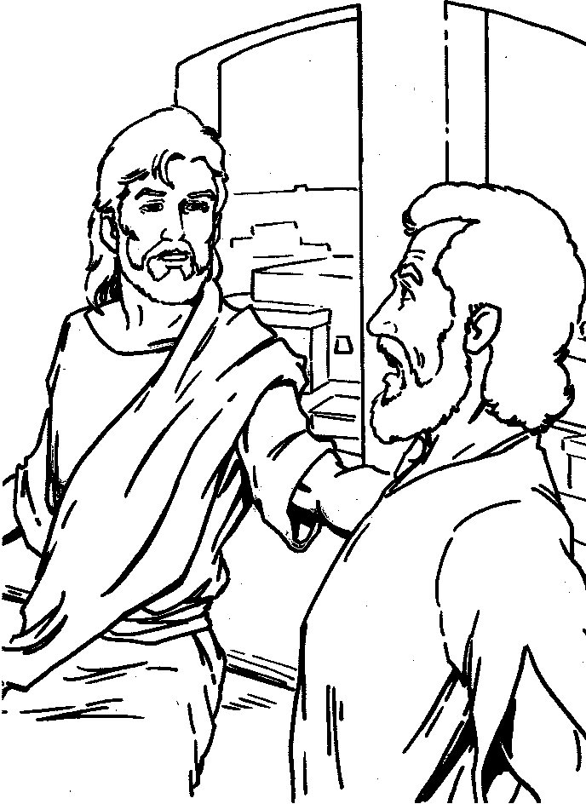
he went out and wept bitterly.
Have you seen Peter’s failure? He had been with the Master about three and a half years at seen all the miracles He performed. Even when Jesus warned him of the coming failure, he had on the spur of the moment, confirmed he would never do so. But when the due time came, he forgot all that.
In our lives also we must not allow our spurred feelings to decide our steps. We must watch and must pray! We must accept Gods will
Reference: Memory Verse
Mu. 26:47-75, ”. Keep watch and pray that you will not fall into
Lk. 22:47-61, Jn.18:3-27 temptation. The spirit is willing, but the flesh is
(Mtt 26:41)
-
- After arrest where did the soldiers take Jesus to?...........................................
- Where was Peter sitting? ................................................................
- What was Peter doing in the courtyard? ..................................................
- How many times did Peter denies Jesus? ...................................................
- How many times did the cock crow?... ............. ......... .........................

