LESSON 17
Purifying
the House of God
Do you know about festivals? Some people celebrate Deewali and Durgapuja, some Christmas and Easter and some Id and Moharam.
But God had commanded the Israelites to celebrate seven feasts in a year. They had their I (The house of God) in Jerusalem. In order to celebrate the feasts, all had to come to the ten Jerusalem. Among the seven, the first was the festival of Passover.
Jesus and His disciples reached the temple in Jerusalem during the festival of Passover. Do you know what was the temple made for? For worshipping God. It was supposed to be clean and tidy because God's presence was there. But the condition of the Temple was quite different when Jesus visited there..  The temple was unclean everywhere. The outer enclosure was filled with oxen, sheep and the wicket-crates of pigeons. The people were busy selling and buying these on bargain for offering on the altar.  There were money changers who exchanged money for the people who arrived from various countries. With all this, the Temple was turned into a | 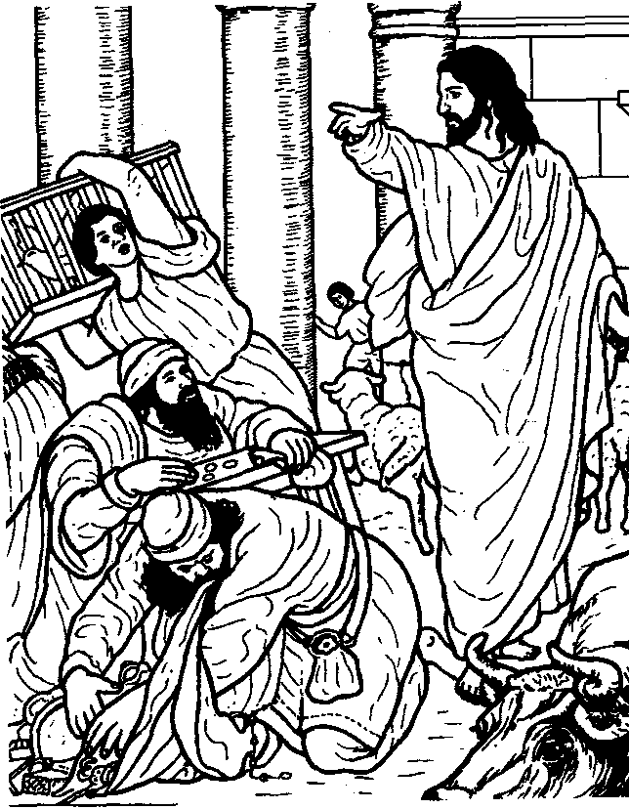

--42-
marketplace! Jesus could not tolerate it.
Jesus having made a whip of chords drove all the animals out of the Temple. He overturned the tables of the money-changers and scattered their coins. He ordered the men who sold pigeons "Take them out of here! Stop making my Father's house a market place!"
Immediately all the traders rushed out in panic with their goods. Thus Jesus purified the Temple.
Now God does not live in temples. He now wants to live in us. The Bible clearly tells us that our body is the Temple of God. So we must keep ourselves clean and pure for God to live in us. We must neither contaminate our body and soul by smoking and drinking nor harm ourselves by drugs an( dirty life.
We must glorify God with our body:
Legs ⁻Use them forgoing to the Church,
Not to any unholy places.
Hands ⁻Use them to help others.
Not to slap and hurt others. Tongue - Use it to praise God Not to abuse others.
Brain - Use it for thinking and planning good matters
Not to plan evil schemes.
Take care that God takes glory through you in this way.
Reference: Memory Verse
Surely you know that you are God's temple and that God's spirit live
John 2:12-21 in you. So if anyone destroys God's temple, God will destroy him. For
God's temple is holy, and you yourselves are his temple. (Cori.3:16,17)
- When did Jesus and His disciples reach the temple?.......................................
- How should be the temple for worship?...................................................
- How many festivals did Israel Have?......................................................
- Why should we keep our body clean and tidy?............................................
- How can we contaminate our body?......................................................
- How can we use our body to glorify Go ...................................................
Memorise the seven festivals of Israelites:  1) The Passover 2)  3) The sheaf of the first-fruits 4)  5) The Blast of trumpets 6)  7) The Festival of booths | The Unleavened Bread  The Pentecost ₍Fiftieth day) The Day of atonement

